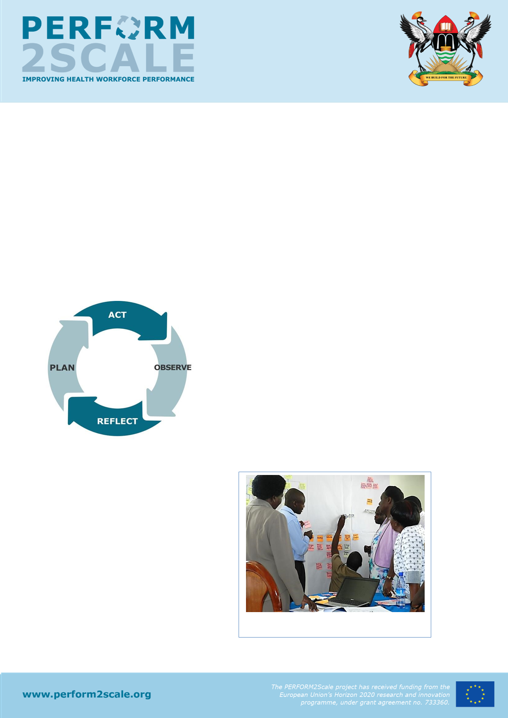
Project briefing: Uganda
Update: February 2018

The need for strengthening management/workforce performance at district level
In Uganda, we need health workers with relevant skill mix to improve health workforce performance in order to achieve Universal Health Coverage. Managers at district level are being supported to improve annual planning and implementation in the devolved structure of service delivery. They also need a simple and sustainable way of improving workforce performance management and the relevant management competencies such as leadership, planning and performance appraisal.

The PERFORM management strengthening intervention
The PERFORM initiative developed a management strengthening intervention (MSI) and tested it with District Health Management Teams (DHMT) in Ghana, Uganda and Tanzania from 2012-14. The MSI used an action research approach (see Figure 1) to enable the
teams to analyse their own problems related to
workforce performance and develop appropriate
workplans (plan); implement the workplans (act) and
learn about management from the experience (observe
and reflect). The MSI was facilitated by national
research teams in each country through meetings, short
workshops (Figure 2) and joint meetings of DHMTs, and
follow-up support. The teams tackled problems such as
poor supervision, absenteeism and ineffective staff
appraisal systems.
They developed integrated strategies to be included in the annual district plans, largely using available
Figure 1: the action research cycle

resources. The evaluation of the MSI
showed that it helped to strengthen
management for health workforce
performance. Some strategies were even
attributed to improving service delivery.
For example, in Ghana, improved
supervision of Community Health Officers
led to better record-keeping and
immunization defaulter tracing, and
ultimately reduced drop-out rates and
higher vaccination coverage. The MSI
was also convenient for the DHMTs – Figure 2: problem analysis by DHMT in Uganda
fitting in with their busy schedules – and
promoted collaboration both within the district team and between district teams.
DHMTs wanted the use of the MSI to continue and suggested that the approach should be expanded to more districts.

What are the benefits of the MSI to the DHMTs?
Deliver results (figure 3): PERFORM2Scale is an action research project - this means that once you determine the best ways to improve performance, you can implement these changes and monitor their effects in your districts.
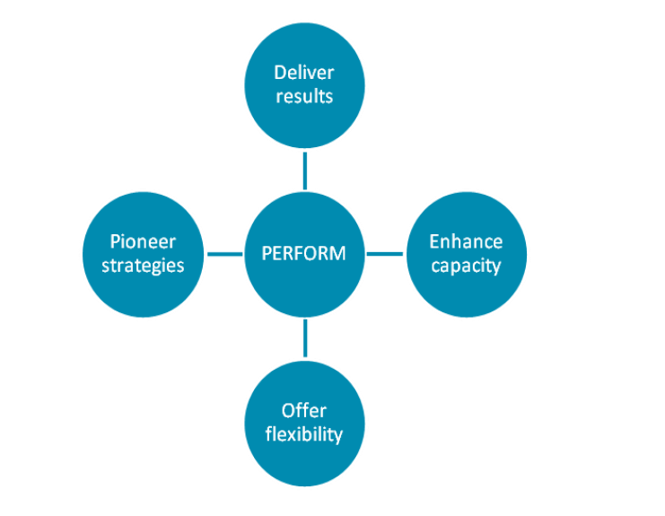
Enhance capacity: The action research approach will contribute to your skills and abilities as a DHMT to resolve problems and maximise the use of your resources.
Offer flexibility: You will have the autonomy to design your own strategies for improving the performance of your workforce, with the support of PERFORM researchers. We will work with you to implement these strategies and observe their effects.
Pioneer improvements: You are the first districts to be involved in PERFORM and are therefore pioneers for our project. We hope to utilise learning from PERFORM to support improved health workforce performance in other districts and potentially other countries.
Figure 3: Benefits of the MSI to the DHMT
Expansion/Scaling-up the PERFORM MSI
To increase the impact of the MSI on strengthening district-level management and improving health workforce performance, it needs to be implemented both continuously (Figure 4) and at scale. This project, which will also be conducted in Malawi and Uganda, seeks to increase learning across different contexts. The aim of the five-year PERFORM2Scale initiative is to develop and validate a costed national scale-up process for the MSI. The expansion/scale-up strategy includes working with government and other employers, and relevant stakeholders to integrate the initiative into existing national level management structures to sustain the implementation of the MSI at district level in Ghana.

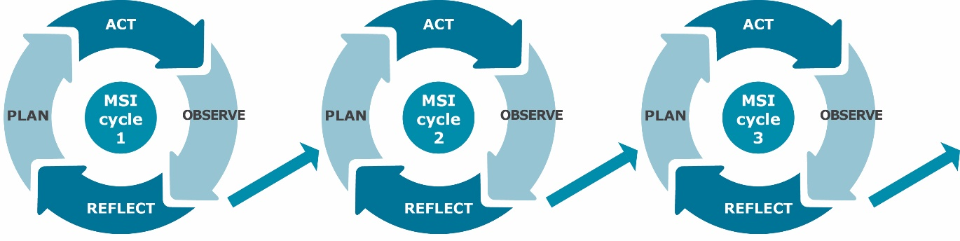
Figure 4: The MSI cycle will help DHMTs to solve problems and gradually improve their management competencies
What has happened so far?
In the inception year we established the National Scale-up Steering group (NSSG) and Resource Team (RT) to oversee and implement the scale up process. We also selected the first District Group (DG1) consisting of 3 districts. You are one of these selected districts.
The PERFORM2Scale project has received funding
fro
m t
he
European Union’s Horizon 2020 research and
innovat
ion
programme, under grant agreement n
o. 733360.
www.perform2scale.org
What happens next?
Over the next year, the CRT and the RT will support you to conduct the first MSI Cycle. Figure 5 shows the activities that will happen. Each of these activities is then described in detail below.

Observe & Reflect
Plan
Act
Figure 5: Activities within MSI
Orientation visit
The Country Research Team (CRT) – researchers from the School of Public Health (University of Ghana) - along with the RT will visit the district. This is the first visit to the study district, and will include a meeting with the DHMT and other relevant stakeholders in the district. The purpose of the orientation visit is to provide more information about PERFORM2Scale, what is expected of the DHMT throughout the study, and develop a plan for the first MSI cycle which synchronises with the other DHMTs in the District Group and is in line with the overall scale-up plan.
During the orientation visit, the CRT with the RT will give a presentation about PERFORM2 Scale, provide the project brief, and answer any questions. During the visit, the CRT will also introduce the two tools that are used for the district situation analysis, explaining the purpose of the tools and what data to collect.
Situation analysis
In this 4-week phase, the DHMT, with support from the CRT and RT will conduct a situation analysis where they identify health workforce and service delivery problems in their districts. Attention will be paid to differences experienced by women and men, and gender and equity concerns in service delivery. There are two tools that will be used to conduct the situation analysis: District Situation Analysis Tool and the HMIS Synthesis Tool. Both tools use data or knowledge that already exists in the district. The CRT will go through these tools with you.
The CRT and RT will make one visit to each district to support the DHMT in the situation analysis. In this visit, the CRT and RT will:
- Review the tools and the data collected with the DHMT
- Help answer any problems with the data collection
- Facilitate the DHMT to identify the health workforce performance problems or other problems with clear link to workforce performance that they want to address, and
- Promote the use of data to support the problems identified. It is important that wherever possible, there should be data that supports the problem e.g. number of appraisals per year show that very few staff are appraised.
The outputs of the situation analysis are: a completed District Situation Analysis Tool; a completed HMIS tool; and a list of workforce performance problems or other problems with clear link to workforce performance that are prioritised by the DHMT. This leads into the in-depth problem analysis. This will be done in MSI Workshop 1.
MSI Workshop 1: problem analysis
In this 2-day workshop members of DHMTs in the three districts of the District Group come together to review findings of their situation analyses, and conduct an analysis of one of the problems they have identified.

The DHMTs bring to the workshop: the completed District Situation Analysis Tool; the completed HMIS tool; and the list of prioritised problems - workforce performance problems or other problems with clear link to workforce performance. Each DHMT will present their situation analysis and their prioritised list of problems, and receive feedback from the other DHMTs as well as the CRT and RT. Each DHMT will then select the problem that they want to address and do an in-depth analysis of this problem.
Further problem analysis in the district
As not all DHMT members will have been able to participate in MSI Workshop 1, it is important that learning from the workshop is taken back to the full DHMT. This 4-week period will allow for collection of more data to inform the problem analysis where necessary, and revision and refinement of the problem analysis taking in the perspectives of the wider DHMT. The DHMT will then bring this revised problem analysis to MSI Workshop 2.
MSI Workshop 2: development of strategies and workplan
This will mainly be done in MSI Workshop 2. In this 2 ½ - day workshop members of DHMTs in the three districts of the District Group come together to refine the problem analysis, and develop a workplan for human resources/health system strategies to address problems identified in the situation analysis. During the workshop, CRT and RT will agree with the DHMT on support processes during the implementation period, as well as ways to observe and reflect on the implementation and effects of the strategies.
Having selected the human resources/health system strategies, the research team is now in
a position to develop a workplan for implementation. Participating districts will likely have existing plans and targets, so first consider how these may be modified to address the prioritised problems. The plan is not necessarily a complex document. It can be as simple as a table noting the issues set out in bullet points:
- Identify the particular strategy you want to use
- Identify the activities needed to implement the strategy
- Develop targets based on expected improvements in performance when compared to the situation analysis. The targets should be time-bound
- Identify linkages to other strategies
Strategies should always be developed within local budgets, integrated into local planning cycles and take account of authority constraints.
Implementing the workplan
In this stage, the DHMT will implement the strategies developed in the workplan over a period of 8 months.
Observing and reflecting
In this stage, it is important that the CRT and RT encourage the DHMT to really observe and document how each of the strategies are being implemented. The DHMT can use the indicators developed in the Workplan to monitor the effects of the strategies.
The reflection stage is a time when the DHMT, with support from the CRT and RT, can step back and take stock of whether, and to what extent, problems have been solved or have evolved over the period of the action research project. They can also think about why problems have or have not resolved. This is an important part of the learning process. It is also the most challenging stage of the cycle.
If a DHMT finds that one of the strategies they are implementing is not working – or affecting another strategy negatively (for example there is a risk that the upgrading training will have a negative impact on the strategy of reducing staff absence – especially if the number of staff in the facilities is already very low), they can consider modifying it or even dropping it. Modifying or dropping a strategy is not considered a failure.
Rather it is important to understand why they were dropped. When the DHMT reflects on why something changed, the DHMT are in fact learning to develop appropriate strategies to improve workforce performance within their own unique district. Alternatively, new strategies may be added if, for example, a DHMT identifies that part of the overall problem has not yet been addressed.
There are several approaches and tools that can help reflection take place. The DHMT can keep a reflective diary which helps to document what strategies they have implemented and how they implemented them, and then reflect on what went well, what didn’t go so well and why, and think about how to do things differently.
Support visits by CRT and RT: the CRT and RT will visit each district and have a face to face meeting with the DHMT on two occasions during the acting / implementing of the workplan. During these visits, the CRT and RT can review the workplan and the diary with the DHMT, discuss the implementation of the strategies, any challenges faced in implementing them and how they were solved, any effects of the strategies so far and evidence for these effects. This will help the DHMT reflect on what has gone well, what has gone not so well, and what changes to make.

These visits could be supplemented by discussions via telephone call or e-mail, although it will be more difficult to have an in-depth discussion and exploration of the implementation, with a range of DHMT members.
Inter-district meetings: The three DHMTs in the District Group will come together in an inter-district meeting. This will be held in one of the three districts or an alternative convenient location. The main purpose of this meeting is for DHMTs to share progress and learning about implementation of the strategies, how they have solved any problems, and any effects of the strategies. The key aspect of this meeting is bringing the districts together and helping them learn from each other.

The following years
In Year 3 the MSI cycle will continue in District Group 1 and a new cycle will start in District Group 2.
In Year 4 the MSI cycles will continue in DG1 and DG2 and a new cycle will start in DG4. During this period the NSSG and RT will take increasing responsibility for organising scale-up and facilitation of the MSIs and will manage the planning and implementation for existing and new cycles in Year 5.
Research
The research component of PERFORM2Scale will be managed by the School of Public Health (University of Ghana), starting with an Initial Context Analysis study in Year 1 and including process and outcome evaluation – including costing in Years 2-4 and concluding in Year 5.
Read More:
Browse the website www.perform2scale.org
Follow us on Twitter @PERFORM2scale

Contact us at Makerere University School of Public Health:
Freddie Ssengoba ssengoba@musph.ac.ug
Xavier Nsabagasani xnsabagasani@musph.ac.ug

