Inter-District Meeting Report
Add country
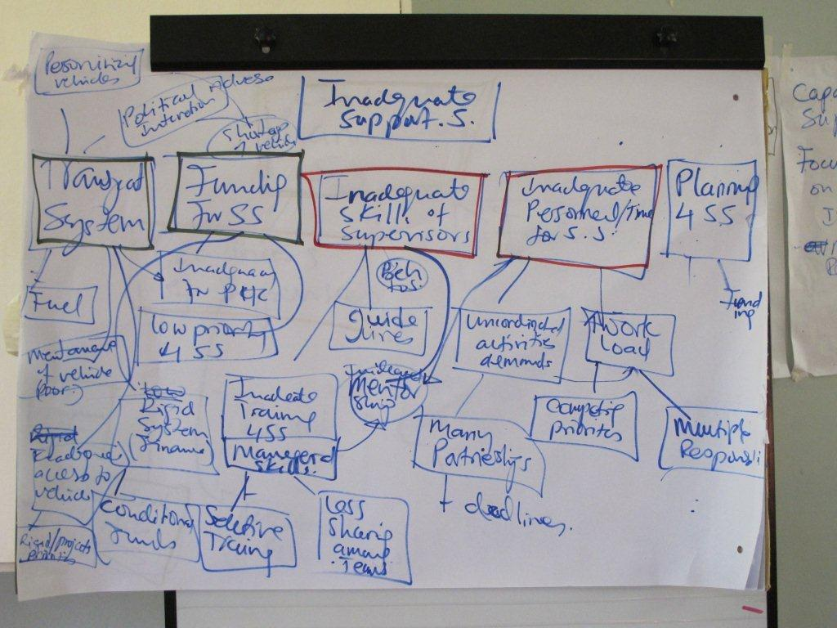
(add photo of meeting)

Add location
Add date
For DHMT (does not include Annex 5 - reflections on meeting)
For Consortium (includes Annex 5)

Table of Contents
Introduction 3
Meeting Objectives 4
Outputs of the Meeting 5
Detailed Description of the Meeting 6
Annex 1: List of participants 7
Annex 2: Meeting programme 8
Annex 3: District progress presentations 9
Annex 4: District Action Plans 10
Annex 5: Reflections on Inter-district Meeting 11

Introduction

Meeting Objectives

Outputs of the Meeting

Detailed Description of the Meeting

Annex 1: List of participants

NO | NAME | GENDER | POSITION HELD | ORGANISATION | DISTRICT
1
2
3
4
5
6
7
8
9
10
11
12
13
14
15
16
17
18
19
20
21
22

Annex 2: Meeting programme

Annex 3: District progress presentations

Annex 4: District Action Plans

Annex 5: Reflections on Inter-district Meeting (consortium report only)

What went well with the meeting?
What did no go so well with the meeting?
Reflections on MSI
Reflections on Scale-Up

