Problem analysis using fishbone diagram
The fishbone diagram is called such because it looks like the spine of a fish. When using this diagram, the problem statement (see separate guidance on how to formulate a problem statement) that is being discussed is written at the head of the fish (red in Figure 1).
The team then identifies the various causes for the problem and places them under the categories. The most common categories are identified in Figure 1 in orange; however, the labels can be changed depending on the problem. This is not complicated — it is simply a way of brainstorming potential causes to the problem and sorting the ideas into categories to make them easier to review and discuss. Remember to consider gender when looking at the causes of the problem: is this cause different for men and women?
The categories commonly used are: people, methods (including procedures, policies and protocols), machines / equipment and materials and the environment.

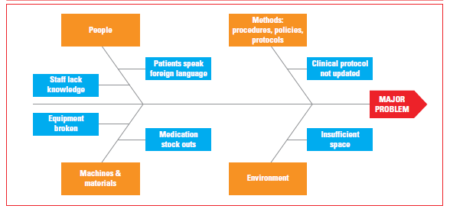
Figure 1: Example of fishbone diagram (reference: https://www.healthynewbornnetwork.org/hnn-content/uploads/EMEN-QI-GUIDE-.pdf

