Problem tree analysis
Problem tree analysis helps to find solutions by mapping out, in a structured way, the anatomy of cause and effect around an issue. Problem tree analysis should be used with the District Health Management Team at MSI Workshop 1 in order to get a clearer view of the human resources/health systems problems that are being faced.

Step 1: Discuss and agree the problem or issue to be analysed. Do not worry if it seems like a broad topic because the problem tree will help break it down. The problem statement (see separate guidance on how to formulate a problem statement) or issue is written in the centre of a flip chart (or on the wall, if using post-it notes) and becomes the ‘trunk’ of the tree or the ‘focal problem’. The wording does not need to be exact as the roots and branches will further define it. The focal problem should describe an actual issue that everyone feels passionately about.

Step 2: The group then identify the causes of the focal problem - these become the roots. This will usually be a chain of causes – for example, A leads to B which leads to C which contributes to the focal problem. This exercise is sometimes referred to as the “5 whys”.

Step 3: Next, identify the consequences – these become the branches. These causes and consequences can be created on post-it notes or cards, perhaps individually or in pairs, so that they can be arranged in a cause-and-effect logic. The heart of the exercise is the discussion, debate and dialogue that is generated as factors are arranged and rearranged. Time should be allowed for people to explain their feelings and reasoning, and record related ideas and points that come up on separate flip chart paper under titles such as solutions, concerns and decisions.

Questions to stimulate discussion might include:
- Does this represent the reality? Are the economic, political and socio-cultural dimensions to the problem considered? Has gender been considered?
- Which causes and consequences are getting better, which are getting worse and which are staying the same?
- What are the most serious consequences? Which are of most concern? What criteria are important to us in thinking about a way forward?
- Which causes are easiest / most difficult to address? What possible solutions or options might there be? Where could a policy change help address a cause or consequence, or create a solution?
- Are the causes of the problem gender specific? How do the problems impact differently for women or men, boys and girls?
Figures 1 and 2 provide examples of problem tree analyses.
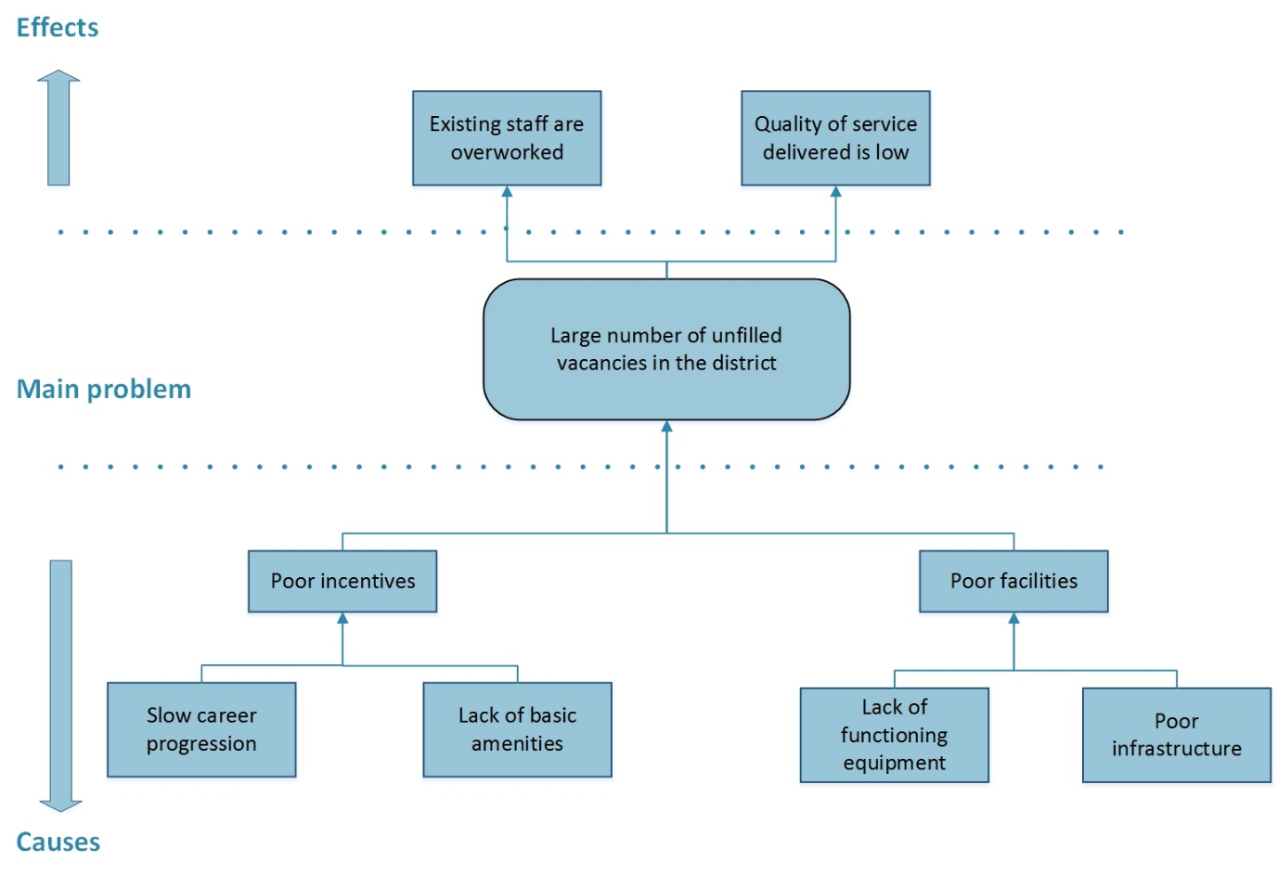

Figure 1: Example of a problem tree analysis

Figure 2: Example of a problem tree analysis

