MSI Workshop 1 Report
Add country
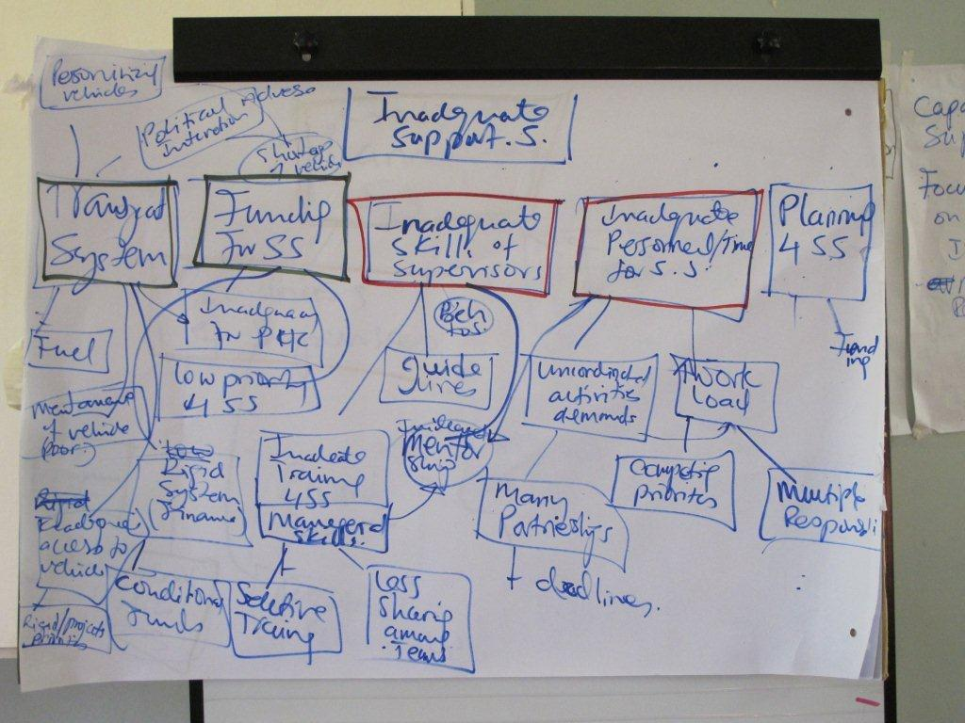(add photo of problem tree from workshop)

Add location
Add date

For DHMT (does not include Annex 7 - reflections on workshop)
For Consortium (includes Annex 7)
Table of Contents

Introduction 3
Workshop Objectives 4
Outputs of the Workshop 5
Day 1 of the Workshop – detailed description 6
Day 2 of the Workshop – detailed description 7
Annex 1: List of participants 8
Annex 2: Workshop programme 9
Annex 3: Observation checklist for situation analysis presentation 10
Annex 4: Situation analysis presentations 11
Annex 5: District Problem Analysis (Initial) 12
Annex 6: Workshop Evaluation Questionnaire Findings 13
Annex 7: Reflections on MSI Workshop 1 14

Introduction

Workshop Objectives

Outputs of the Workshop

Day 1 of the Workshop – detailed description

Day 2 of the Workshop – detailed description

Annex 1: List of participants

NO | NAME | GENDER | POSITION HELD | ORGANISATION | DISTRICT
1
2
3
4
5
6
7
8
9
10
11
12
13
14
15
16
17
18
19
20
21
22

Annex 2: Workshop programme

Annex 3: Observation checklist for situation analysis presentation

Annex 4: Situation analysis presentations

Annex 5: District Problem Analysis (Initial)

Annex 6: Workshop Evaluation Questionnaire Findings

Annex 7: Reflections on MSI Workshop 1 (for CRT report only)

What went well in the workshop?
What went not so well in the workshop?
Reflections on MSI
Reflections on Scale-Up
Reflections on workshop evaluation

