MSI Workshop 2 Report
Add country
(add photo from workshop)
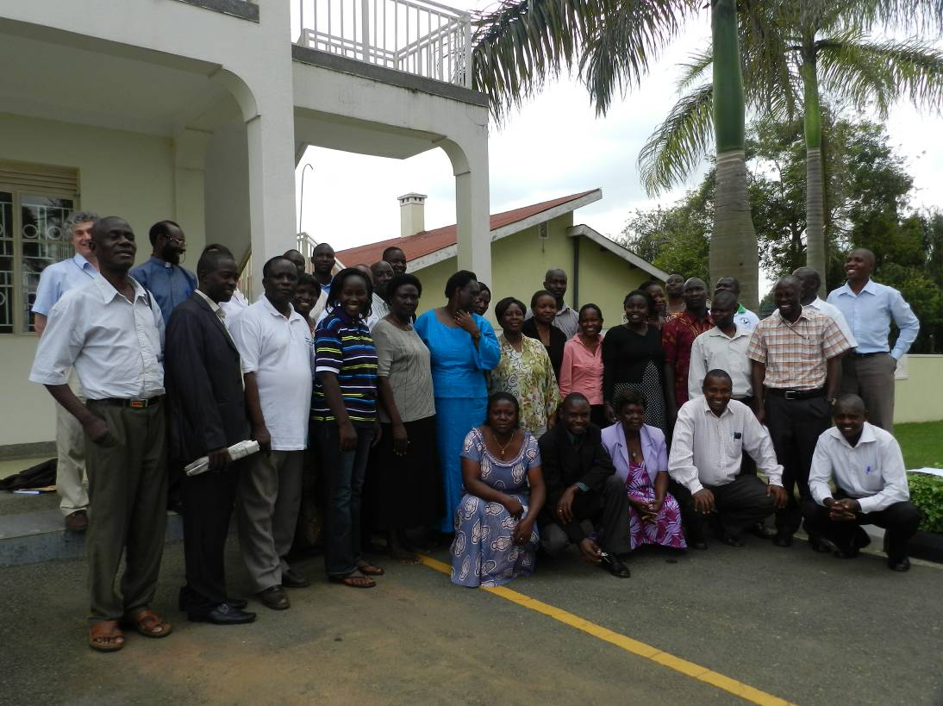
Add location
Add date

For DHMT (does not include Annex 6 - reflections on workshop)
For Consortium (includes Annex 6)
Table of Contents

Introduction 3
Workshop Objectives 4
Outputs of the Workshop 5
Day 1 of the Workshop – detailed description 6
Day 2 of the Workshop – detailed description 7
Day 3 of the Workshop – detailed description 8
Annex 1: List of participants 9
Annex 2: Workshop programme 10
Annex 3: District Problem Analysis (final) 11
Annex 4: District workplans 12
Annex 5: Workshop Evaluation Questionnaire Findings 13
Annex 6: Reflections on MSI Workshop 2 14

Introduction

Workshop Objectives

Outputs of the Workshop

Day 1 of the Workshop – detailed description

Day 2 of the Workshop – detailed description

Day 3 of the Workshop – detailed description

Annex 1: List of participants

NO | NAME | GENDER | POSITION HELD | ORGANISATION | DISTRICT
1
2
3
4
5
6
7
8
9
10
11
12
13
14
15
16
17
18
19
20
21
22

Annex 2: Workshop programme

Annex 3: District Problem Analysis (final)

Annex 4: District workplans

Annex 5: Workshop Evaluation Questionnaire Findings

Annex 6: Reflections on MSI Workshop 2 (for CRT report only)

What went well in the workshop?
What went not so well in the workshop?
Reflections on MSI
Reflections on Scale-Up
Reflections on workshop evaluation

